**Managing Change and Disruptive Innovations**

* **The Case for change**
* **Organizational Change: Any alteration of people, structure, or technology in an organization.**
* **Change agent: someone who acts as a catalyst and assumes the responsibility for managing the change process.**

**External and Internal Forces for Change**

|  |  |
| --- | --- |
| **External** | **Internal** |
| **Changing consumer needs and wants** | **New organizational strategy** |
| **New governmental laws** | **Change in composition of workforce** |
| **Changing technology** | **New equipment** |
| **Economic changes** | **Changing employee attitudes** |

**External Factors:**

* **Changing consumer needs and wants**
* **New governmental laws**
* **Changing technology**
* **Economic changes**

**Internal Factors:**

* **New organizational strategy**
* **Change in composition of workforce**
* **New equipment**
* **Changing employee attitudes**
* **Calm Waters Versus White-Water Rapids Metaphors**
* **Calm waters metaphor:**
  + **Unfreezing the status quo**
  + **Changing to a new state**
  + 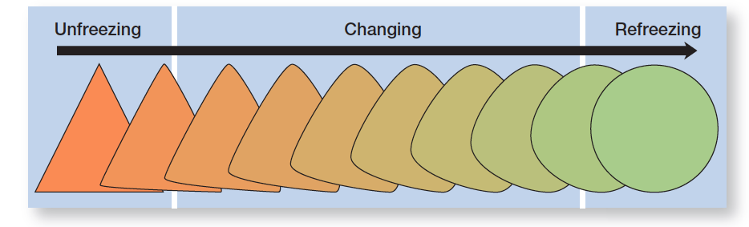**Refreezing to make the change permanent**

**White-Water Rapids Metaphor**

* **White-water rapids metaphor**: the lack of environmental stability and predictability requires that managers and organizations continually adapt and manage change actively to survive

**Reactive Versus Proactive Change Processes**

* **Reactive**: reacting to a situation that has occurred
* The left side of the figure shows four arrow heads. Each points to a rectangular box on the right side of the figure. The arrows are labeled, from top to bottom: Strategy, Structure, Technology, and People. The rectangles are labeled, from top to bottom: Modifying the approach to ensuring the organization's success; Structural components and structural design; Work processes, methods, and equipment, and Attitudes, expectations, perceptions, and behavior – individual and group.**Proactive**:acting in advance of a situation

Four types of change

Types of Change: Strategy

Failure to change strategy when circumstances dictate could undermine a company’s success.

**Types of Change: Structure**

* Changing structural components
* Changing structural design

**Types of Change: Technology**

* New equipment, tools, or methods
* Automation
* Computerization

**Types of Change: People**

* **Organizational development**: change methods that focus on people and the nature and quality of interpersonal work relationships

**Popular OD Techniques**

**Why Do People Resist Change?**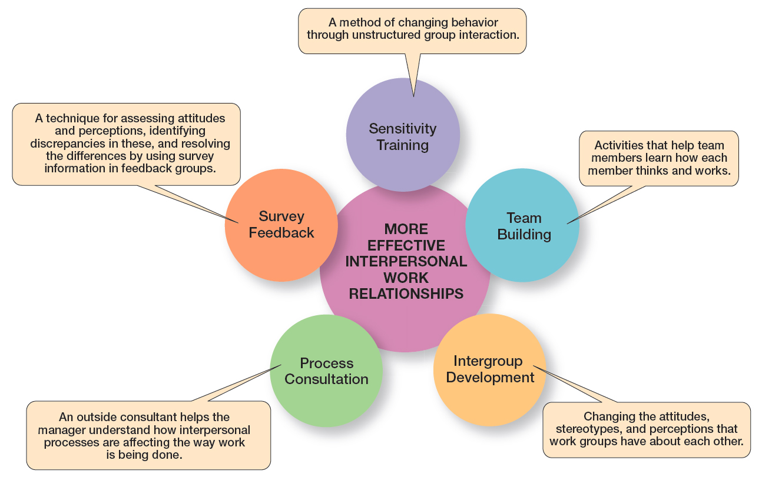

* Uncertainty
* Habit
* Fear of loss
* Belief change is inconsistent with goals of organization

**Techniques for Reducing Resistance to Change?**

* Education and communication
* Participation
* Facilitation and support
* Negotiation
* Manipulation and co-optation
* Coercion

**Techniques for Reducing Resistance to Change**

|  |  |  |  |
| --- | --- | --- | --- |
| **Technique** | **When Used** | **Advantage** | **Disadvantage** |
| Education and communication | When resistance is due to misinformation | Clear up misunderstandings | May not work when mutual trust and credibility are lacking |
| Participation | When resisters have the expertise to make a contribution | Increase involvement and acceptance | Time-consuming; has potential for a poor solution |
| Facilitation and support | When resisters are fearful and anxiety ridden | Can facilitate needed adjustments | Expensive; no guarantee of success |
| Negotiation | When resistance comes from a powerful group | Can “buy” commitment | Potentially high cost; opens doors for others to apply pressure too |
| Manipulation and co-optation | When a powerful group’s endorsement is needed | Inexpensive, easy way to gain support | Can back re, causing change agent to lose credibility |
| Coercion | When a powerful group’s endorsement is needed | Inexpensive, easy way to gain support | May be illegal; may undermine change agent’s credibility |

**Leading Change**

* Managers can make change happen successfully by:
  + making organization change capable
  + understanding their own role in process
  + giving employees a role in the change

**Change-Capable Organizations**

|  |
| --- |
| **Characteristics** |
| **Link the present and the future**. Think of work as more than an extension of the past; think about future opportunities and issues and factor them into today’s decisions. |
| **Make learning a way of life*.*** Change-friendly organizations excel at knowledge sharing and management. |
| **Actively support and encourage day-to-day improvements and changes.**  Successful change can come from the small changes as well as the big ones. |
| **Ensure diverse teams**. Diversity ensures that things won’t be done like they’ve always been done. |
| **Encourage mavericks.** Because their ideas and approaches are outside the mainstream, mavericks can help bring about radical change. |
| **Shelter breakthroughs.** Change-friendly organizations have found ways to protect those breakthrough ideas. |
| **Integrate technology.** Use technology to implement changes. |
| **Build and deepen trust.** People are more likely to support changes when the organization’s culture is trusting and managers have credibility and integrity. |
| **Couple permanence with perpetual change.** Because change is the only constant, companies need to figure out how to protect their core strengths during times of change. |
| **Support an entrepreneurial mindset.** Many younger employees bring a more entrepreneurial mindset to organizations and can serve as catalysts for radical change. |

**Creating a Culture for Change**

* The fact that an organization’s culture is made up of relatively stable and permanent characteristics tends to make it very resistant to change.

**Understanding the Situational Factors**

* Conditions that facilitate change:
  + dramatic crisis occurs
  + leadership changes hands
  + culture is weak

**Exhibit 7-7 Changing Culture**

|  |
| --- |
| **Strategies for Managing Cultural Change** |
| **Set the tone through management behavior; top managers, particularly, need to be positive role models.** |
| **Create new stories, symbols, and rituals to replace those currently in use.** |
| **Select, promote, and support employees who adopt the new values.** |
| **Redesign socialization processes to align with the new values.** |
| **To encourage acceptance of the new values, change the reward system.** |
| **Replace unwritten norms with clearly specified expectations.** |
| **Shake up current subcultures through job transfers, job rotation, and/or terminations.** |
| **Work to get consensus through employee participation and creating a climate with a high level of trust.** |

**Employee Stress**

* **Stress: the adverse reaction people have to excessive pressure placed on them from extraordinary demands, constraints, or opportunities**
* **Stressors: factors that cause stress**

**What Causes Stress?**

* **Task demands**
* **Role demands**
  + **Role conflicts**
  + **Role overload**
  + **Role ambiguity**
* **Interpersonal demands**
* **Organization structure**
* **Organizational leadership**

**Personal Factors**

* **Type A personality: people who have a chronic sense of urgency and an excessive competitive drive**
* **Type B personality: people who are relaxed and easygoing and accept change easily**

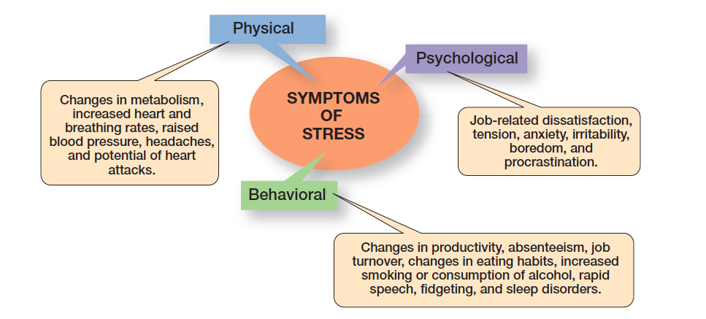**Figure 7-8 Symptoms of Stress**

**How Can Stress Be Reduced?**

* Realistic job preview during selection process
* Performance planning program, e.g. MBO
* Job redesign
* Addressing personal stress
  + counseling
  + time management programs
  + wellness programs

**Creativity Versus Innovation**

* **Creativity**: the ability to combine ideas in a unique way or to make unusual associations between ideas
* **Innovation**: taking creative ideas and turning them into useful products or work methods

**Stimulating and Nurturing Innovation**

* An environment that stimulates innovation includes three variables: the organization’s structure, culture, and human resource practices.

**Figure 7-9 Innovation Variables**

**Structural Variables**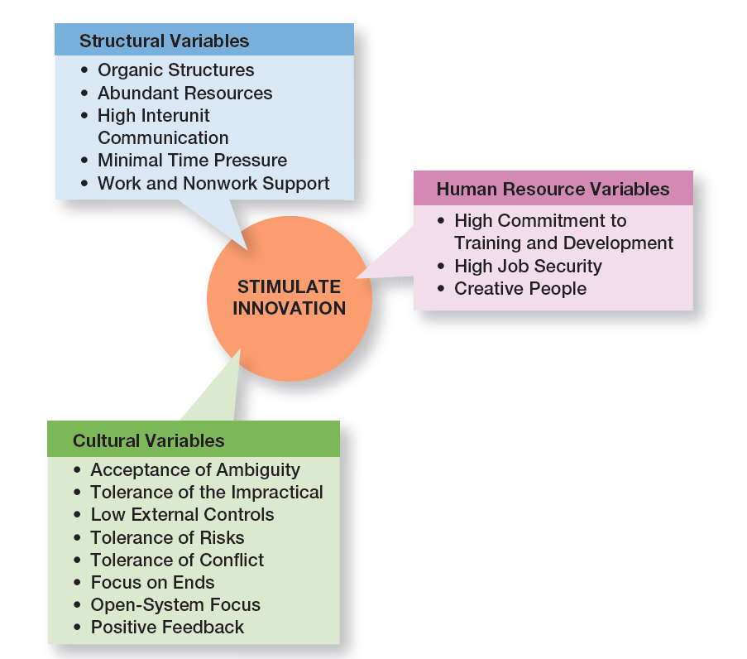

* Organic structures
* Abundant resources
* High interunit communication
* Minimal time pressure
* Work and nonwork support

**Cultural Variables**

* Acceptance of ambiguity
* Tolerance of the impractical
* Low external controls
* Tolerance of risks
* Tolerance of conflict
* Focus on ends
* Open-system focus
* Positive feedback

**Human Resource Variables**

* **Idea champion**: individual who actively and enthusiastically supports new ideas, builds support, overcomes resistance, and ensures that innovations are implemented

**Innovation and Design Thinking**

* When a business approaches innovation with a design-thinking mentality, the emphasis is on getting a deeper understanding of what customers need and want.

**Disruptive Innovation Definition**

* **Disruptive innovation**: innovations in products, services, or processes that radically change an industry’s rules of the game
* **Sustaining innovation**: small and incremental changes in established products rather than dramatic breakthroughs

**Exhibit 7-10 Examples of Past Disruptive Innovators**

|  |  |  |  |
| --- | --- | --- | --- |
| **Established Business** | **Disruptor** | **Established Business** | **Disruptor** |
| Compact disc | Apple iTunes | Traveler’s checks | ATMs and Visa |
| Carbon paper | Xerox copy machine | Encyclopedias | Wikipedia |
| Canvas tennis shoes | Nike athletic shoes | Newspaper  classified ads | Craig’s List |
| Portable radio | Sony Walkman | AM/FM radio stations | Sirius XM |
| Sony Walkman | Apple iPod | Tax preparation services | Intuit’s Turbo Tax |
| Typewriters | IBM PC | Yellow Pages | Google |
| Weekly news magazines | CNN | Paper maps | Garmin’s GPS |
| TV networks | Cable and Netflix | Paperback books | Kindle |
| Local travel agencies | Expedia | Lawyers | Legal Zoom |
| Stockbrokers | eTrade | Taxis | Uber |

**Why Disruptive Innovation Is Important**

* Disruptive innovations are a threat to many established businesses, and responding with sustaining innovations isn’t enough.

**Who’s Vulnerable?**

* Large, established, and highly profitable organizations are most vulnerable to disruptive innovations because they have the most to lose and are most vested in their current markets and technologies.

**Implications**

* For entrepreneurs
* For corporate managers
  + **Skunkworks**: a small group within a large organization, given a high degree of autonomy and unhampered by corporate bureaucracy, whose mission is to develop a project primarily for the sake of radical innovation
* For career planning

**Review Learning Objective 7.1**

* **Describe making the case for change.**
  + Change agent
  + External forces
  + Internal forces

**Review Learning Objective 7.2**

* **Compare and contrast views on the change process.**
  + Calm waters metaphor
  + White water rapids metaphor
  + Lewin’s three-step model

**Review Learning Objective 7.3**

* **Classify areas of organizational change.**
  + Strategy
  + Structure
  + Technology
  + People

**Review Learning Objective 7.4**

* **Explain how to manage change.**
  + People resist change because of uncertainty, habit, concern over personal loss, and the belief that the change is not in the organization’s best interest.
  + Techniques for reducing resistance to change include: education and communication, participation, facilitation, negotiation, manipulation and co-optation, and coercion

**Review Learning Objective 7.5**

* **Discuss contemporary issues in managing change.**
  + Managers lead the change process by:
    - Making organization change capable
    - Understanding own role
    - Giving employees a role in change process
  + Managers help employees deal with stress by:
    - Ensuring employees’ abilities match job
    - Improving organizational communication
    - Using a performance planning program
    - Redesigning jobs

**Review Learning Objective 7.6**

* **Describe techniques for stimulating innovation.**
  + Creativity
  + Innovation
  + Design thinking and innovation

**Review Learning Objective 7.7**

* **Explain why managing disruptive technology is important.**
  + Disruptive innovation exists when a smaller company with fewer resources is able to successfully challenge established incumbent businesses.
  + Disruptive innovation presents an as- set to organizations that recognize the market potential of the technology.

**STRATEGIC MANAGEMENT**

**Concept of strategic management: ‘Large-scale action plan for interacting with the environment to achieve long-term goals.’**

* Strategic management process
* Importance of strategic management
* Levels of strategy
* Strategic management process:
* ‘Process through which managers formulate and implement strategies geared to optimising strategic goal achievement, given available environmental and internal conditions.’

Strategic management process:

* Strategy formulation
  + Identify mission & goals
  + Competitive situation analysis (external & internal)
  + Develop/formulate strategies to achieve identified goals
* Strategy implementation
  + Implement plans
  + Control/monitor execution of plans

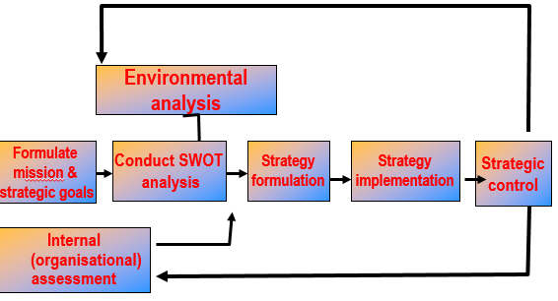

**Importance of strategic management**

Important because:

* 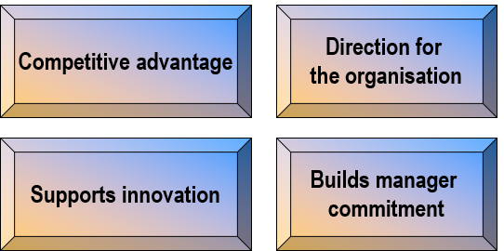Helps organisations develop a competitive advantage (significant edge over competition in dealing with competitive forces).
* Provides a sense of long-term direction for organisation members.
* Highlights need for innovation.
* Process involves members and fosters understanding of goals/strategy.

**Levels of strategy**

Corporate level

Business level

Functional level

Corporate level strategy:

‘Type of strategy addressing what businesses the organisation will operate, how strategies of those businesses will be co-ordinated to strengthen the organisation’s competitive position, and how resources will be allocated among businesses.’

Business level strategy:

‘Type of strategy concentrating on the best means of competing within a particular business while also supporting corporate level strategy.’

Functional level strategy:

‘Type of strategy focussing on action plans for managing a particular functional area within a business in a way that supports business level strategy.’

**Competitive analysis in strategy formulation**

Before managers devise an effective strategy for getting a competitive edge, they must analyse the organisation’s competitive situation.

This is done through:

* Environmental analysis (external)
* Organisational assessment (internal)

**Environmental assessment**

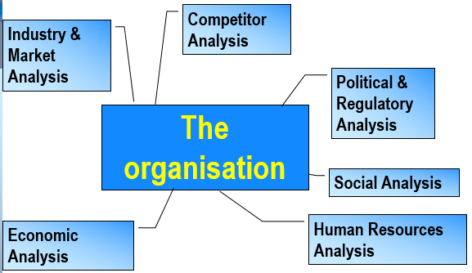

**Competitive analysis in strategy formulation**

SWOT analysis:

Method of analysing an organisation’s competitive situation involving assessing organisational strengths (S), weaknesses (W), environmental opportunities (O) and threats (T).

Environmental assessment:

Five competitive forces model (Porter):

1. Rivalry
2. Bargaining power of customers
3. Bargaining power of suppliers
4. Threat of new entrants
5. Threat of substitute products/services.

Organisational assessment:

* **Value**  
  Do the firm’s resources & capabilities add value by enabling it to exploit opportunities or neutralise threats?
* **Rareness**  
  How many competing firms already possess these valuable resources & capabilities?
* **Imitability**  
  Do firms without a resource or capability face a cost disadvantage?
* **Organisation**  
  Is the firm organised to exploit competitive potential of its resources & capabilities?

**Formulating corporate level strategy**

Corporate level strategy is the overall strategy an organisation follows. Its development involves selecting a grand strategy and using portfolio-strategy approaches to determine the various businesses making up the organisation:

* 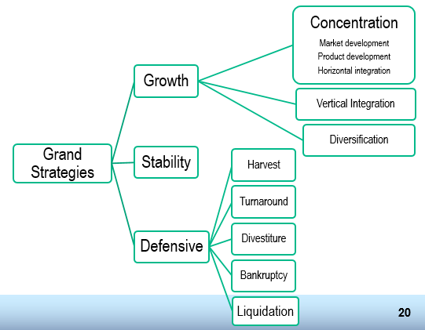Grand strategy
* Portfolio-strategy approaches.

Portfolio strategies:

Method of analysing an organisation’s mix of businesses in terms of both individual and collective contributions to strategic goals.

* BCG growth–share matrix

Compares businesses in an organisation’s portfolio on the basis of relative market market share and market growth rate.

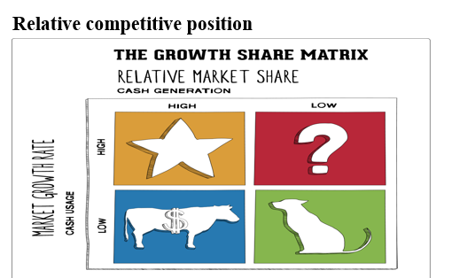**BCG growth-share matrix**

* **Dogs.** Dogs hold low market share compared to competitors and operate in a slowly growing market.
  + **Strategic choices:** Retranchement, divestiture, liquidation
* **Cash cows.** Cash cows are the most profitable brands and should be “milked” to provide as much cash as possible. The cash gained from “cows” should be invested into stars to support their further growth.
  + **Strategic choices:** Product development, diversification, divestiture, retrenchment
* **Stars.** Stars operate in high growth industries and maintain high market share. Stars are both cash generators and cash users.
  + **Strategic choices:** Vertical integration, horizontal integration, market penetration, market development, product development
* **Question marks.** Question marks are the brands that require much closer consideration. They hold low market share in fast growing markets consuming large amount of cash and incurring losses.
  + **Strategic choices:** Market penetration, market development, product development, divestiture

**Formulating business level strategy**

* Business level strategy is concerned with how a particular business competes.
* The best known approach for strategy development is based on Porter’s research.

Generic business strategies:

Porter outlined three generic business level strategies to gain competitive advantage over other firms operating in the same industry.

Generic business strategies (Porter):

* Cost leadership strategy

Emphasises operational efficiency i.e. overall costs are lower than competitors.

* Differentiation strategy

Attempts to develop products/services viewed as unique in the industry.

* Focus strategy

Concentration on a segment, portion of a market.

Generic business strategies (Porter):

* Cost leadership strategy

Emphasises operational efficiency i.e. overall costs are lower than competitors.

* Differentiation strategy

Attempts to develop products/services viewed as unique in the industry.

* Focus strategy

Concentration on a segment, portion of a market.

**Strategy implementation**

Strategy implementation involves management activities needed to put the strategy in motion, institute strategic controls for monitoring progress, and ultimately achieve organisation goals.

**Lecture summary**

* Concept of strategic management
  + Process
  + Importance
  + Levels
* Competitive analysis in strategy formulation
  + SWOT analysis
  + Environmental assessment
  + Organisational assessment
* Formulating corporate level strategy
  + Grand strategy
  + Portfolio strategies
* Formulating business level strategy
  + Porter generic strategies: cost, differentiation & focus
* Formulating corporate level strategy
* Strategy implementation
  + Control systems & adjustments

**MOTIVATION**

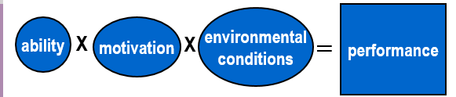**NATURE OF MOTIVATION**

Motivation is the force energising, or giving direction to, behaviour.

It is a complex interaction of behaviours, needs, rewards, reinforcement and cognitive activities.

**NEEDS THEORIES**

* Hierarchy-of-needs theory (Maslow)
* Two-factor theory (Herzberg)
* ERG theory (Aldefer)
* Acquired-needs theory (McClelland)

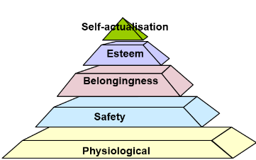

Hierarchy-of-needs theory (Maslow)

Theory arguing that individual needs form a five-level hierarchy

**Two-factor theory (Herzberg)**

Herzberg’s theory that hygiene factors are necessary to keep workers from feeling

dissatisfied, but only motivators can lead workers to feel satisfied and motivated.

* Hygiene factors

Factors seeming to make individuals feel dissatisfied with their jobs

* Motivators

Factors seeming to make individuals feel satisfied with their jobs

**Two-factor theory (Herzberg)**

**Hygiene factors**

* PAY
* WORKING CONDITIONS
* SUPERVISORS
* COMPANY POLICIES
* FRINGE BENEFITS

*These factors help prevent dissatisfaction.*

**Two-factor theory (Herzberg)**

**Motivators**

* ACHIEVEMENT
* RESPONSIBILITY
* WORK ITSELF
* RECOGNITION
* GROWTH
* ADVANCEMENT

*These factors promote satisfaction.*

**ERG theory (Alderfer)**

Alternative to Maslow’s hierarchy of needs theory, which argues that there are three levels of individual needs.

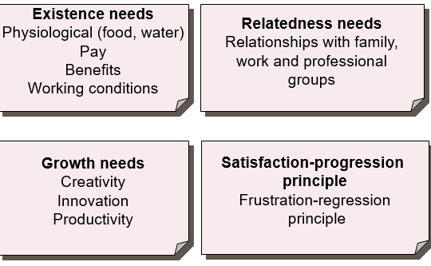**ERG theory (Alderfer)**

* Existence needs

Material & physiological desires

* Relatedness needs

Need to be accepted & to interact

* Growth needs

Need for creativity & productive impact

**Acquired-needs theory (McClelland)**

Theory stating that our needs are acquired or learned on the basis

of our life experiences.

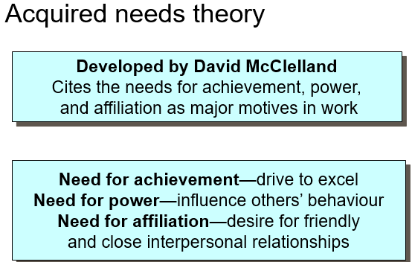**Acquired needs theory (McClelland)**

* **Need for achievement**

Desire to accomplish challenging tasks

* **Need for affiliation**

Desire to have warm, friendly relationships

* **Need for power**

Desire to influence & control

* **COGNITIVE THEORIES**
* Expectancy theory
* Equity theory
* Goal-setting theory
* **Expectancy theory (Vroom)**
* Theory arguing that we consider   
  three main issues (effort-performance, performance-outcome, and valence) before we expend effort necessary to perform at a given level.

**Expectancy theory (Vroom)**

* Effort-performance expectancy

Our assessment of the probability our efforts will lead to the required level of performance.

* Performance-outcome expectancy

Our assessment of the probability our successful performance will lead to desired outcomes.

* Valence

Our assessment of anticipated value of various outcomes or rewards.

**Equity theory (Adams)**

Theory arguing that we prefer situations of balance, or equity.

Implications for managers:

* + Communication essential to assess equity/inequity perceptions in employees
  + Complementary to expectancy theory
* **Goal-setting theory**
* Goal-setting theory [technique] works by focusing attention & action, mobilising effort, increasing persistence, & encouraging the development of strategy to achieve goals.

**REINFORCEMENT THEORY**

Theory arguing that our behaviour can be explained by consequences in the environment.

**Types of reinforcement:**

* **Positive**

Uses pleasant, rewarding consequences to encourage desired behaviour. Use of shaping.

* **Negative**

Stimuli (unpleasant) so an individual will engage in the desired behaviour to stop the stimuli.

**Types of reinforcement (cont.):**

* **Extinction**

Stopping previously available positive outcomes from a behaviour to decrease the behaviour.

* **Punishment**

Providing negative consequences to decrease or discourage a behaviour.

**SOCIAL LEARNING THEORY**

**Social learning theory (Bandura)**

Theory arguing that learning occurs through continuous reciprocal interaction of our behaviours, various personal factors and environmental forces.

Learning occurs by continuous

interaction between our behaviours,

personal factors and environmental

forces, viz.:

* Symbolic processes
* Self-control/regulation
* Vicarious learning

**LECTURE SUMMARY**

* Nature of motivation

Motivational process

Motivation & performance

* Needs theories

Hierarchy of needs

Two-factor

ERG

Acquired needs

* Cognitive theories

Expectancy

Equity

Goal-setting

* Reinforcement theory

Positive, negative, extinction, punishment as reinforcement

* Social learning theory

Symbolic processes, self-control, vicarious learning